Assignment-1: Connect and disconnect with login Access

* What happens when you login a non-existent users or username?
  + Provide Screenshot and What you understand, explain in short brief?

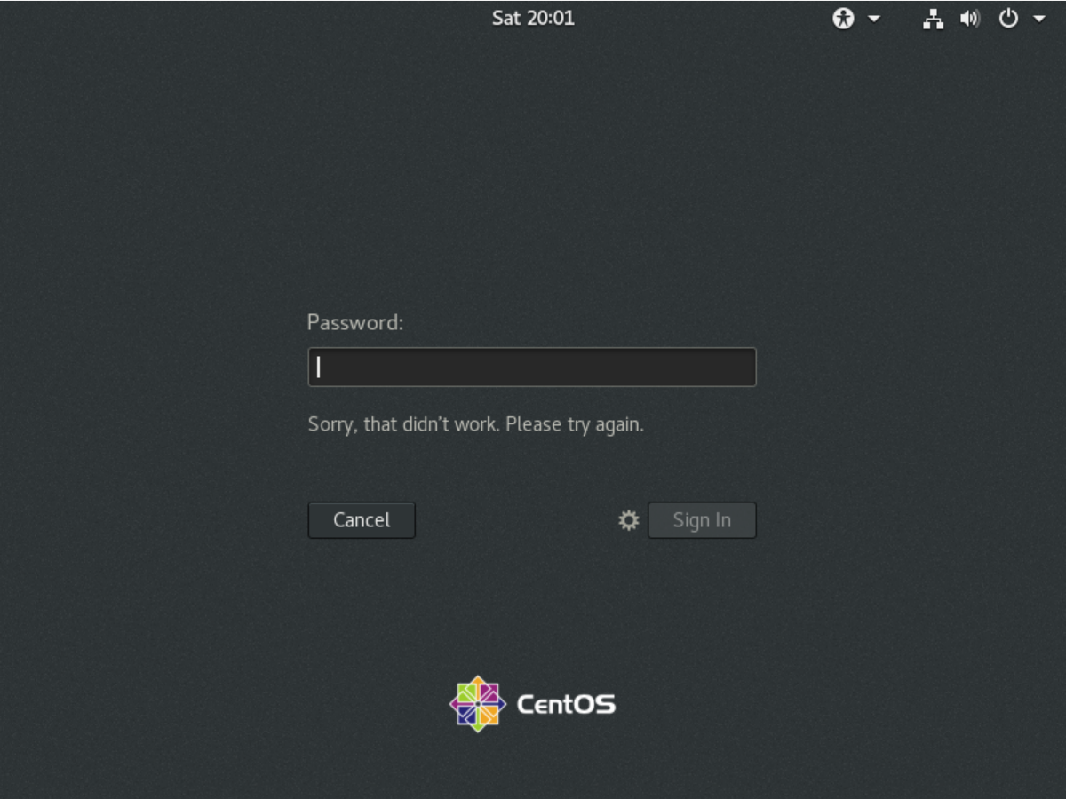

• When we try to login with non-existent users or username, we get rejected from login to machine. Because the OS won’t be able to detect the username which was not set up earlier while installing it.